SUMMER 2024

Q.1 (a) Write any 4 advantages and 4 applications of computer graphics

Advantages of Computer Graphics:
- Efficient Data Visualization:
  - Converts large sets of numerical or textual data into visual formats like graphs, charts, or diagrams.
  - Helps in quick understanding and decision-making.
- Interactivity:
  - Enhances user interaction through GUIs (Graphical User Interfaces).
  - Example: Drag-and-drop, clickable icons in operating systems.
- Realistic Simulations:
  - Provides realistic simulations in training (e.g., pilot simulators).
  - Reduces the risk and cost associated with real-world training.
- High Precision and Quality:
  - Allows detailed and accurate representation of objects.
  - Essential in CAD for architectural or mechanical designs.

Applications of Computer Graphics:
- Entertainment:
  - Used in movies, games, and animation (e.g., Pixar movies, 3D games).
- Medical Imaging:
  - For non-invasive examinations like MRI, CT scans—visualizing internal organs.
- Engineering Drawing (CAD):
  - Used for designing automobiles, buildings, electrical layouts, etc.
- Education and Training:
  - Used for virtual labs, simulations, and interactive learning modules.
📚 Additional Applications: Satellite imaging, photo enhancement, weather maps, cartography, etc.

Q.1 (b) Explain Touch Screen Display with Diagram

Touch Screen Display:
- A touch screen is both an input and output device.
- It detects touch-based interactions like tap, swipe, drag, etc.

- 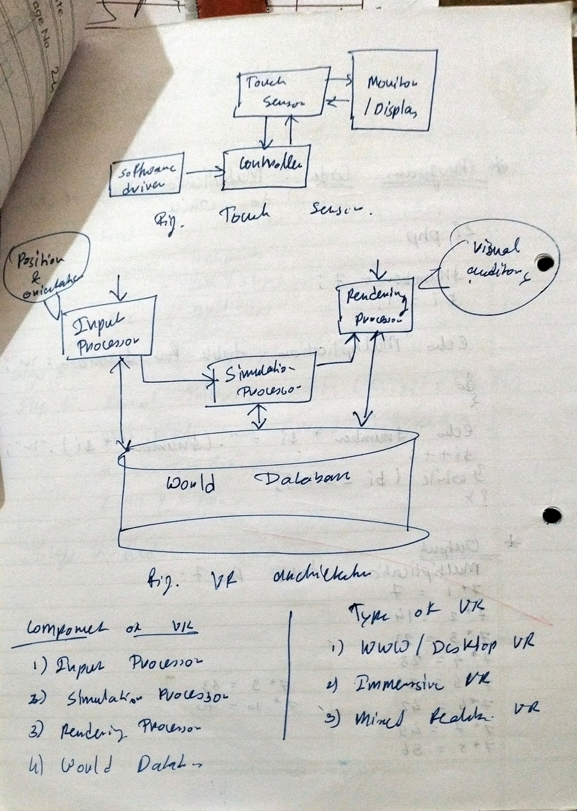

Types of Touch Screen Technologies:
- Resistive Touch:
  - Two flexible sheets are coated with resistive material and separated.
  - Pressure causes contact and registers the position.
- Capacitive Touch:
  - Uses electrical conductivity of the human body.
  - Touch changes the capacitance at a specific location.
- Surface Wave:
  - Uses ultrasonic waves; touch absorbs waves, changes response.

Diagram:
Here's a basic conceptual diagram of a resistive touch screen (I'll describe it, but I can also send a visual if you need one):
lua
Copy code
---------------------
| Top Glass Layer | <- Flexible layer
|---------------------|
| Spacer Dots |
|---------------------|
| Bottom Glass Layer | <- Conductive layer
---------------------
When the user touches the top layer, it bends to contact the bottom layer. The controller calculates the coordinates of the touch.
✅ Touch screens are widely used in mobile phones, ATMs, and kiosks.

Q.1 (c) Explain in brief:

i) Cartesian Coordinate System:
- A 2D coordinate system where each point is represented as (x, y).
- The X-axis is horizontal, and the Y-axis is vertical.
- The origin (0, 0) is the center point.
- Commonly used in graphics to define object locations.

ii) Polar Coordinate System:
- Each point is represented by (r, θ):
  - r = distance from the origin
  - θ = angle from the reference direction (usually X-axis)
- Useful for circular or angular objects.
ℹ️ Cartesian system is good for rectangular layouts; polar is useful for radial or rotational layouts.

Q.2(A) Attempt any ONE

(a) Draw and label eight-way symmetry property of circle
A circle has 8-way symmetry which is used to minimize computation when drawing. If you calculate a point (x, y) on the circumference in the first octant, then you can reflect it to get 7 other points using symmetry.

8 Symmetric Points of a Circle (Centered at origin):
Given a point (x, y), the 8 symmetric points are:
- (x, y)
- (y, x)
- (-x, y)
- (-y, x)
- (-x, -y)
- (-y, -x)
- (x, -y)
- (y, -x)

Diagram Description:
yaml
Copy code
|
* | *
|
*-----------+-----------*
|
* | *
|
The * represents symmetric points around the center.
This principle helps speed up circle drawing in algorithms like Bresenham and Midpoint Circle Algorithm by calculating only one octant and mirroring the rest.

(b) Define seed fill technique of polygon filling

Seed Fill Technique:
- Seed fill algorithms fill a region with a specific color starting from a “seed” point.
- Common in paint tools (like bucket fill).

Types:
- Flood Fill:
  - Fills the area with new color until a boundary or a different color is encountered.
  - Uses 4-connect or 8-connect neighbors.
- Boundary Fill:
  - Starts from inside and fills outward until the boundary color is hit.
  - Requires predefined boundary color.

Flood Fill Example Algorithm (Recursive):
c
Copy code
void floodFill(int x, int y, int new_color, int old_color) {
if (getpixel(x, y) == old_color) {
putpixel(x, y, new_color);
floodFill(x+1, y, new_color, old_color);
floodFill(x-1, y, new_color, old_color);
floodFill(x, y+1, new_color, old_color);
floodFill(x, y-1, new_color, old_color);
}
}
Used in games, paint apps, and modeling tools.

Q.2(B) Attempt any THREE

(a) Boundary Fill Procedure of Polygon
- Fills area until boundary color is found.
- Requires a known boundary color.

Algorithm (4-connected):
void boundaryFill4(int x, int y, int fill_color,int boundary_color) {
if(getpixel(x, y) != boundary_color && getpixel(x, y) != fill_color) {
putpixel(x, y, fill_color);
boundaryFill4(x + 1, y, fill_color, boundary_color);
boundaryFill4(x, y + 1, fill_color, boundary_color);
boundaryFill4(x - 1, y, fill_color, boundary_color);
boundaryFill4(x, y - 1, fill_color, boundary_color);
}
}
Used in graphic editors and drawing applications.

(b) Rasterize the line from (1,2) to (7,6) using Bresenham's Line Algorithm

- In Notes.

(c) Steps of Midpoint Circle Drawing Algorithm

Idea:
- Only compute pixels for the first octant and use symmetry.
- Use decision parameter P = x² + y² – r²

Algorithm Steps:
- Start from point (0, r)
- Compute initial decision parameter: P = 1 - r
- For each x from 0 to y:
  - Plot (x, y) and all symmetric points
  - If P < 0: next point is (x+1, y)
    - Update: P = P + 2x + 3
  - Else:
    - Decrement y
    - Update: P = P + 2(x - y) + 5
- Repeat until x > y
Efficient circle generation method without floating-point math.

(d) Inside-Outside Test using Winding Number

Winding Number Method:
- A mathematical method to test whether a point lies inside or outside a polygon.

Steps:
- Draw a ray from the point to the right.
- Count how many times it crosses polygon edges:
  - If winding number ≠ 0 → point is inside.
  - If winding number = 0 → point is outside.

Diagram Concept:
- Point A inside polygon → winding number = 2 (looped around twice)
- Point B outside polygon → winding number = 0
Useful for complex polygons, unlike even-odd rule which can fail in self-intersecting shapes.

Q.3(A) Attempt any ONE

a) Define 2D Transformation
2D Transformation refers to operations that are applied to a two-dimensional object to change its:
- Position (Translation)
- Size (Scaling)
- Orientation (Rotation)
- Shape (Shearing)
- Reflection
These transformations are represented as matrix operations, allowing us to easily apply multiple transformations by matrix multiplication.

Why use 2D Transformations?
- For object movement in animation or games.
- For mapping models from world space to screen space in graphics.
- To simulate effects like mirroring, enlarging, rotating, etc.
Example: To move a square 2 units right and 3 units up, we apply a translation matrix with Tx=2, Ty=3.

b) Write 2D transformation matrix for:
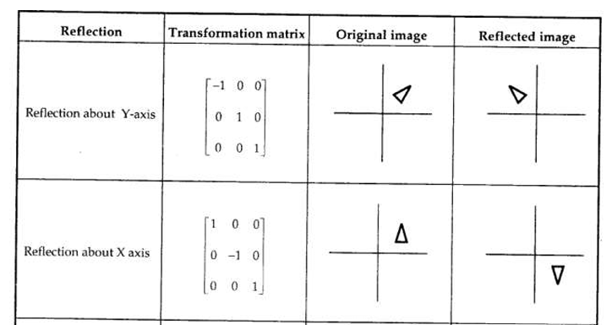

Q.3(B) Attempt any THREE

a) Define Homogeneous Coordinates + Transformation Matrix for:

Homogeneous Coordinates:
- Adds a third coordinate (h), typically set to 1.
- A point (x, y) becomes (x, y, 1).
- Benefits:
  - Allows combining multiple transformations into one matrix.
  - Simplifies matrix multiplication.
  - Enables translations as matrix operations.

i) Translation Matrix (Tx, Ty):
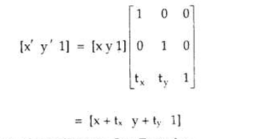

ii) Rotation Matrix (angle θ):
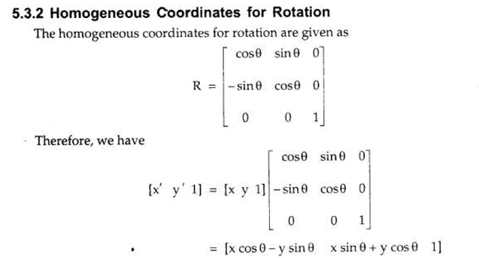

b) Derive Transformation Matrix for 2D Rotation About Arbitrary Point (x₀, y₀)
In NOtes

c) Define 3D Transformation + 3D Scaling w.r.t Origin

3D Transformation:
Transforms objects in three-dimensional space using operations such as:
- Translation
- Scaling
- Rotation
- Reflection
Uses 4x4 matrices and homogeneous coordinates (x, y, z, 1).

3D Scaling w.r.t Origin:
Where:
- Sx, Sy, Sz are scaling factors along x, y, z axes.
Example: Doubling an object in size along all axes → Sx = Sy = Sz = 2

d) Shearing Transformation on a Square

In Notes

✅

Q.4 (B) Attempt any THREE

a) Draw and Explain Workstation Transformation
Workstation transformation is used to map world coordinate system to device coordinate system using two mappings:
- World Coordinate → Normalized Coordinate
- Normalized Coordinate → Device Coordinate (Viewport)
Steps:
- Define window and viewport.
- Apply normalization transformation.
- Map normalized coordinates to viewport using scaling and translation.
In Notes

b) 2D Sutherland-Hodgman Polygon Clipping Algorithm
Used to clip a polygon against a rectangular clipping window.
Steps:
- Initialize input list with polygon vertices.
- For each clipping boundary (left, right, top, bottom):
  - Start with empty output list.
  - Process each edge of polygon:
    - If both vertices inside: add second vertex.
    - If going from outside to inside: add intersection + second vertex.
    - If going from inside to outside: add only intersection.
    - If both outside: add nothing.
- Output list becomes new input list for next boundary.

c) Workstation Transformation Calculation
Given:
- Window: (1,1) to (3,6)
- Viewport: (0,0) to (½, ½)
Transformation:
- In NOtew
So, any point (x, y) in the window is mapped to:
(x−14,y−110)\left( \frac{x - 1}{4}, \frac{y - 1}{10} \right)(4x−1​,10y−1​)

d) Steps of 2D Cohen-Sutherland Line Clipping
Steps:
- Compute region codes for endpoints.
- If both codes = 0000 → line is inside (accept).
- If AND of codes ≠ 0000 → line is outside (reject).
- Else, calculate intersection with boundary.
  - Replace the outside endpoint with the intersection.
  - Repeat process.
Region Code (4 bits):
- Top (1000), Bottom (0100), Right (0010), Left (0001)

Q.5 (A) Attempt any TWO

a) Four Problems in True Curve Generation
- Complex mathematical equations needed.
- High computational cost.
- Approximation errors.
- Storage of infinite points impossible → approximated by line segments.

b) Two Properties of Bézier Curve
- Always lies within convex hull of its control points.
- Starts and ends at the first and last control points.

c) Two Features of Koch Curve
- Fractal Nature: Self-similar structure at every level.
- Infinite Length: Increases with each iteration while area remains finite.

Q.5 (B) Attempt any TWO

a) Explain Fractal Line and Fractal Surface
Fractal Line:
- A recursive geometric structure that breaks into smaller versions of itself.
- Example: Koch Curve, where each line segment is replaced by 4 new segments.
Fractal Surface:
- A 3D surface with recursive, irregular features.
- Used in terrain generation, mountain modeling in games and simulations.

b) Second Approximation to Koch Curve
Steps:
- Divide each line segment into 3 parts.
- Replace the middle part with two sides of an equilateral triangle.
- Result: 4 segments per original segment.
After 2 iterations:
- 16 segments form a “snowflake-like” shape.

c) Interpolation Technique and Algorithm
Used to draw curves between known points.
Steps:
- Use polynomial functions (e.g., Lagrange).
- Curve passes exactly through sample points.
Simple Linear Interpolation:
c
Copy code
float interpolate(float x0, float y0, float x1, float y1, float x) {
return y0 + ((y1 - y0)/(x1 - x0)) * (x - x0);
}

Q.6 Attempt any TWO

a) Hazards of Graphics Standards
- Incompatibility across platforms.
- Lack of flexibility for advanced features.
- Performance bottlenecks in legacy standards.
- Limited vendor support or implementation inconsistencies.

b) Four Basic Operations of OpenGL
- Vertex Specification – Define shapes using vertex data.
- Transformation – Apply matrix operations to position shapes.
- Clipping – Remove parts outside viewing volume.
- Rasterization – Convert shapes to pixels.
(Additional stages: Shading, Fragment Processing, etc.)

c) i) Principles for good GUI design (Found in full)【50:16†ch4_merged.pdf**]:
- Aesthetically pleasing
- Clarity
- Compatibility
- Comprehensibility

ii) Features of GUI
- Windows, Icons, Menus, Pointers (WIMP)
- Event-driven interaction
- Multitasking support
- Accessibility and responsiveness

WINTER 2024

Q.1(A) Attempt any TWO

a) Write any four advantages of computer graphics in brief
- Visualization of Data:
  - Helps in understanding complex data through graphs, charts, and simulations.
- User-Friendly Interfaces:
  - Enables GUIs that allow users to interact visually with applications (e.g., Windows OS).
- Efficient Design and Simulation:
  - Used in CAD tools for accurate designs in engineering, architecture, and manufacturing.
- Entertainment and Multimedia:
  - Widely used in movies, games, and virtual reality for animation and effects.

b) Differentiate between Raster and Random Scan Display (Any four points)
Feature | Raster Scan | Random Scan
Resolution | Lower resolution | Higher resolution
Drawing Method | Draws pixel-by-pixel in a scanline | Draws picture line-by-line (vector-based)
Modification | Difficult to modify specific shapes | Easy to modify individual shapes
Color & Shading | Easy to fill with color | Hard to fill solid patterns
Refresh Process | Scans whole screen | Refreshes only needed lines
Application | Realistic scenes, photographs | Technical drawings (CAD)
Interlacing | Uses interlacing | Does not use interlacing
Example | CRT TVs, modern displays | Pen plotters, early CAD machines

c) Write any four graphics file formats. Explain any two

Graphics File Formats:
- JPEG – Joint Photographic Experts Group
- PNG – Portable Network Graphics
- GIF – Graphics Interchange Format
- BMP – Bitmap

Explanation of Two Formats:
- JPEG:
  - Used for photos and web graphics.
  - Advantage: High compression.
  - Disadvantage: Lossy format; quality reduces after compression.
- PNG:
  - Lossless compression format.
  - Supports transparency.
  - Advantage: Maintains quality.
  - Disadvantage: Larger file size than JPEG.

Q.2(A) Attempt any ONE

a) Write any two disadvantages of simple DDA line drawing algorithm
- Uses Floating Point Arithmetic:
  - Time-consuming and less efficient on systems without hardware support for floating-point.
- Accuracy Issues:
  - Endpoints may not be accurate due to rounding, especially for steep slopes.

b) Define Polygon. Enlist its types

Polygon:
- A closed 2D shape formed by connecting straight lines end-to-end.
- The lines are called edges or sides, and the connecting points are vertices.

Types of Polygons:
- Convex Polygon – All interior angles < 180°
- Concave Polygon – At least one interior angle > 180°
- Regular Polygon – All sides and angles are equal
- Irregular Polygon – Sides and angles are not equal

Q.2(B) Attempt any THREE

a) Write down scan line fill algorithm used to fill polygon

Steps:
- Find Ymin and Ymax of the polygon.
- For each scan line from Ymin to Ymax:
  - Find intersections with polygon edges.
  - Sort intersection points by increasing X.
  - Fill pixels between pairs of intersections.
Efficient method for filling complex polygons.

b) Write the steps of Bresenham's line drawing algorithm

Steps:
- Calculate dx = x2 - x1, dy = y2 - y1
- Initialize decision parameter p = 2dy – dx
- At each x:
  - If p < 0, next point is (x+1, y)
    - Update p = p + 2dy
  - If p ≥ 0, next point is (x+1, y+1)
    - Update p = p + 2dy – 2dx
Uses only integer operations—more efficient than DDA.

c) Rasterize the line from (1,1) to (5,6) using DDA line drawing algorithm

Step 1:
- x1 = 1, y1 = 1, x2 = 5, y2 = 6
- dx = 4, dy = 5 → length = 5 (since dy > dx)

Step 2:
- Δx = dx / length = 4 / 5 = 0.8
- Δy = dy / length = 5 / 5 = 1

Step 3: Generate Points
- (1.5, 1.5) → (1, 1)
- (2.3, 2.5) → (2, 2)
- (3.1, 3.5) → (3, 3)
- (3.9, 4.5) → (4, 4)
- (4.7, 5.5) → (5, 5)
- (5.5, 6.5) → (5, 6)
Approximate pixels along the line path.

d) Write steps of Midpoint circle drawing algorithm

Steps:
- Start at (0, r)
- Decision parameter: P = 1 – r
- For each x:
  - If P < 0:
    - y = y
    - P = P + 2x + 3
  - Else:
    - y = y – 1
    - P = P + 2x – 2y + 5
  - Plot all 8 symmetrical points for each (x, y)
Draws a circle using integer calculations and symmetry.

Q.3(A) Attempt any ONE

a) Define Translation
Translation is a transformation that moves an object from one location to another.

2D Translation Matrix:
Where Tx and Ty are translations along X and Y axes respectively.

b) Write 3D matrix for rotation about X-axis and Z-axis

Rotation about X-axis:
[10000cos⁡θ−sin⁡θ00sin⁡θcos⁡θ00001]\begin{bmatrix} 1 & 0 & 0 & 0 \\ 0 & \cos\theta & -\sin\theta & 0 \\ 0 & \sin\theta & \cos\theta & 0 \\ 0 & 0 & 0 & 1 \\ \end{bmatrix}​1000​0cosθsinθ0​0−sinθcosθ0​0001​​

Rotation about Z-axis:
[cos⁡θ−sin⁡θ00sin⁡θcos⁡θ0000100001]\begin{bmatrix} \cos\theta & -\sin\theta & 0 & 0 \\ \sin\theta & \cos\theta & 0 & 0 \\ 0 & 0 & 1 & 0 \\ 0 & 0 & 0 & 1 \\ \end{bmatrix}​cosθsinθ00​−sinθcosθ00​0010​0001​​

Q.3(B) Attempt any THREE

a) Define Rotation. Write homogeneous coordinate matrix for 2D rotation
In Notes

b) Translate polygon A(2,5), B(7,10), C(9,1) by 2 in x and 4 in y

Translation Vector: Tx = 2, Ty = 4
New Coordinates:
- A → (2+2, 5+4) = (4, 9)
- B → (7+2, 10+4) = (9, 14)
- C → (9+2, 1+4) = (11, 5)

c) Describe 3D Translation Transformation and Matrix
3D Translation moves a 3D object by Tx, Ty, and Tz.

Matrix:
- In Notes

d) Explain 2D rotation about arbitrary point

Steps:
- Translate point to origin: T(−x₀, −y₀)
- Rotate: R(θ)
- Translate back: T(x₀, y₀)

Final Matrix:
T(x0,y0)⋅R(θ)⋅T(−x0,−y0)T(x₀, y₀) \cdot R(\theta) \cdot T(-x₀, -y₀)T(x0​,y0​)⋅R(θ)⋅T(−x0​,−y0​)

Q4.(A) Attempt any ONE.
a) Define viewport.
b) Define polygon clipping.
(B) Attempt any THREE.
a) Describe processing of polygon vertices in Sutherland -Hodgman polygon clipping algorithm with suitable example.
b) Describe Cohen-Sutherland line clipping algorithm with example.
c) Write the steps of Midpoint subdivision line clipping algorithm.
d) Explain viewing transformation with normalization transformation and workstation transformation.
Q.5.(A) Attempt any TWO.
a) Define interpolation.
b) State any 02 properties of Koch curve.
c) Define fractal line.
(B) Attempt any TWO.
a) Write algorithm for are generation using DDA algorithm.
b) Explain Bezier curve with suitable diagram.
c) Draw and explain second approximation to Hilbert's curve.
Q.6.(A) Attempt any TWO.
a) Explain in brief any four hazards of graphics standard.
b) With neat diagram, explain how openGL works.
c) Describe GUI along with its any two components.

SUMMER 2023

Q.1.(A) Attempt any TWO.
a) List any 4 graphics file formats. Explain any two.
Format | Full Form | Features
JPEG / JPG | Joint Photographic Experts Group | Compressed, lossy format. Good for photos. Small file size, but loses quality.
PNG | Portable Network Graphics | Lossless compression. Supports transparency. Ideal for web graphics and logos.
GIF | Graphics Interchange Format | Limited to 256 colors. Supports animation and transparency.
BMP | Bitmap | Uncompressed. Large file size. Used in Windows environments.
TIFF / TIF | Tagged Image File Format | High-quality, lossless format. Common in scanning and printing.
WEBP | Web Picture format | Developed by Google. Smaller than JPEG/PNG, supports animation and transparency.

📐 2. Vector Image Formats
These use mathematical formulas to represent images. Best for logos, icons, and scalable designs.
Format | Full Form | Features
SVG | Scalable Vector Graphics | XML-based. Scalable without quality loss. Used in web and graphics design.
EPS | Encapsulated PostScript | Used in printing and publishing. Supports vector and bitmap data.
PDF | Portable Document Format | Can contain vector graphics. Common for documents and design.
AI | Adobe Illustrator | Proprietary vector format used by Adobe Illustrator.
CDR | CorelDRAW | Proprietary format used by CorelDRAW.

1. Image Type (Raster vs Vector)
- Raster: Best for photos and detailed images.
- Vector: Best for logos, icons, and scalable designs.

2. Compression Type
- Lossless Compression: Preserves all image data (e.g., PNG, TIFF).
- Lossy Compression: Reduces file size by removing some data (e.g., JPEG).

3. File Size
- Smaller formats (e.g., JPEG, WebP) are better for web use.
- Larger formats (e.g., TIFF, BMP) are better for high-quality printing or archiving.

4. Image Quality
- Choose lossless formats (like PNG, TIFF) when image quality is critical.
- Use lossy formats (like JPEG) when reduced file size is more important than perfect quality.

5. Transparency Support
- Needed for logos and overlay images.
- Supported by: PNG, GIF, SVG, WebP.

6. Animation Support
- Use formats that support animation if needed.
- Supported by: GIF, WebP, APNG.

7. Scalability
- Important for resizing images without quality loss.
- Scalable formats: SVG, AI, PDF (vector formats).

8. Color Depth
- Affects image richness and accuracy.
- High color depth: JPEG, PNG, TIFF.
- Limited color depth: GIF (256 colors only).

9. Software Compatibility
- Ensure the format is supported by your design or viewing software.
- E.g., AI (Adobe Illustrator), CDR (CorelDRAW), SVG (Browsers, editors).

10. Intended Use
Use Case | Recommended Format(s)
Web graphics | PNG, JPEG, SVG, WebP
Print publishing | TIFF, EPS, PDF
Logos/icons | SVG, AI
Animation | GIF, WebP
Document embedding | PDF, PNG

b) Explain Liquid Crystal Display (LCD) with diagram
Definition:
- LCD (Liquid Crystal Display) is a flat panel display that uses liquid crystals to block or allow light to pass through for image formation.
- It works by manipulating polarized light through layers of liquid crystal material.
Structure & Working:
- LCD is made of two glass plates with a liquid crystal layer in between.
- Horizontal transparent conductors are on one glass plate, and vertical conductors are on the other.
- The intersection of horizontal and vertical lines defines each pixel.
- Polarized light passes through the crystals.
  - When voltage is applied, the alignment of the crystals changes → blocks light.
  - No voltage → light passes through → pixel appears bright.
Diagram Description (Text Form):
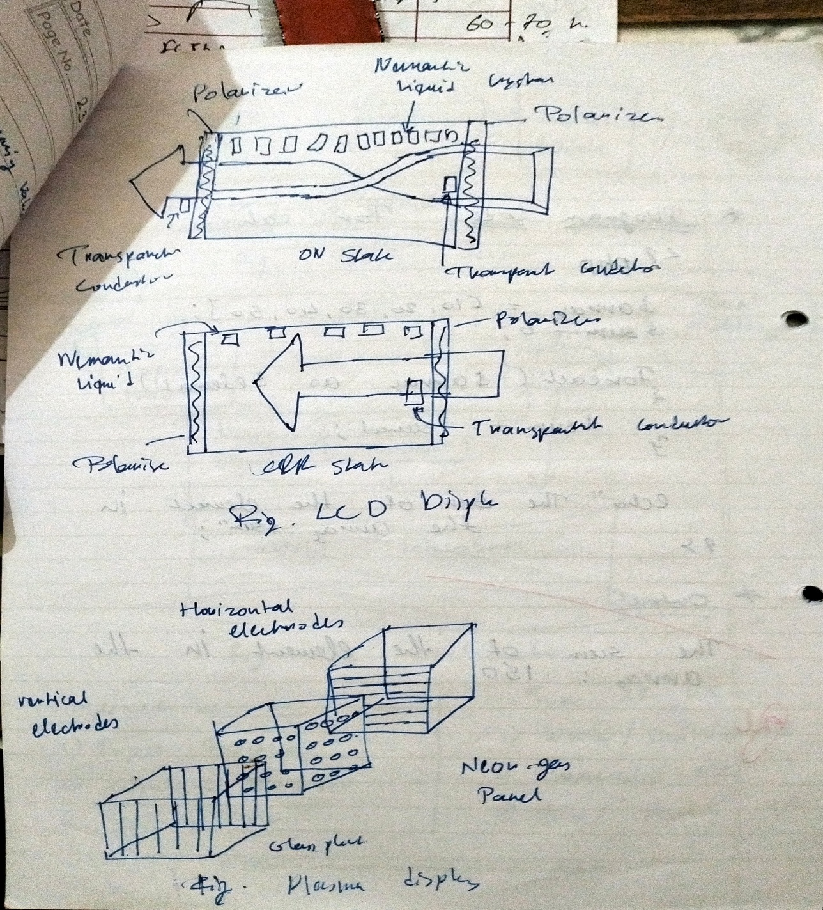
Advantages:
- Lightweight and compact
- Low power consumption
- Sharp image quality
Disadvantages:
- Limited viewing angles
- Dead pixels may appear
- Slower response time than LED
Applications:
- Used in calculators, laptops, watches, medical imaging devices.

c) Draw and explain Cartesian Coordinate System
Cartesian Coordinate System:
- A 2D coordinate system that defines every point using (x, y) values.
- The X-axis is horizontal and Y-axis is vertical.
- The origin (0, 0) is where both axes intersect.
Quadrants:
- Q1: (+x, +y)
- Q2: (−x, +y)
- Q3: (−x, −y)
- Q4: (+x, −y)
Diagram (text-based):
lua
Copy code
Y
↑
Q2 | Q1
<------0------> X
Q3 | Q4
↓
Used for plotting objects in 2D graphics, modeling, and transformations.

Q.2(A) Attempt any ONE

a) 2 Advantages and Disadvantages of DDA
Advantages:
- Easy to understand and implement.
- Faster than using full line equation y = mx + b.
Disadvantages:
- Uses floating-point arithmetic → slower on older systems.
- Orientation-dependent → poor accuracy in steep lines.

b) Define polygon. Name various types
Definition:
A polygon is a closed figure made by connecting straight lines end-to-end. Each corner is a vertex, and each line segment is a side.
Types:
- Convex Polygon
- Concave Polygon
- Regular Polygon
- Irregular Polygon
A polygon must have at least 3 sides and no curved lines.

Q.2(B) Attempt any THREE

a) Define Polygon Filling & Flood Fill Procedure
Polygon Filling:
It refers to coloring the interior area of a polygon.
Flood Fill Algorithm:
- Replaces the interior color with a new color starting from a seed point.
- Continues until all neighboring pixels of the old color are replaced.
Procedure:
c
Copy code
void floodFill(int x, int y, int newColor, int oldColor) {
if(getpixel(x, y) == oldColor) {
putpixel(x, y, newColor);
floodFill(x+1, y, newColor, oldColor);
floodFill(x-1, y, newColor, oldColor);
floodFill(x, y+1, newColor, oldColor);
floodFill(x, y-1, newColor, oldColor);
}
}
Uses 4-connected or 8-connected pixel adjacency.

b) Rasterize Line from (6,6) to (12,9) using Bresenham's Algorithm
Step 1:
- x1 = 6, y1 = 6; x2 = 12, y2 = 9
- dx = 6, dy = 3 → Slope < 1 → X is independent variable
Step 2:
- Initial decision parameter: p = 2dy − dx = 2×3 − 6 = 0
Steps:
- Start at (6,6)
- If p < 0, y unchanged, p = p + 2dy
- If p ≥ 0, y++, p = p + 2dy − 2dx
Resulting Pixels:
- (6,6)
- (7,6)
- (8,7)
- (9,7)
- (10,8)
- (11,8)
- (12,9)

c) Midpoint Circle Drawing Algorithm
Steps:
- Start at (0, r), decision variable: d = 1 - r
- For each x, calculate:
  - If d < 0: d = d + 2x + 3
  - Else: y = y − 1; d = d + 2x − 2y + 5
- Plot 8 symmetric points for each (x, y)
Used to draw a complete circle using symmetry and only integer math.

d) Inside-Outside Test of Polygon
Method: Ray Crossing or Even-Odd Rule
Steps:
- Draw a horizontal ray from the point to the right.
- Count how many times it intersects polygon edges:
  - Odd count → point is inside
  - Even count → point is outside
Point A: Inside → intersects 3 times → odd → inside
Point B: Outside → intersects 2 times → even → outside

Q.3(A) Attempt any ONE

a) Define 3D Transformation
3D Transformation is the process of modifying the position, size, or orientation of 3D objects.
Common types:
- Translation
- Scaling
- Rotation
- Shearing
- Represented using 4x4 matrices with homogeneous coordinates.

b) Define Shearing
Shearing is a transformation that displaces points in a direction, depending on their position along another axis.
Types:
- X-shear: changes x based on y.
- Y-shear: changes y based on x.

Q.3(B) Attempt any THREE

a) 2D Transformation Matrices
In Notes

b) Draw and explain 3D scaling w.r.t origin
Matrix: In Notes

c) 2D Rotation about Arbitrary Point (x₀, y₀)
Steps:
- Translate to origin → T(−x₀, −y₀)
- Rotate → R(θ)
- Translate back → T(x₀, y₀)
Combined Matrix:
In Notes

d) Find Transformation Matrices

i) Translate A(2,5), B(7,10), C(10,2) by Tx = 3, Ty = 2
In Notes
Matrix:
[0.707−0.70700.7070.7070001]\begin{bmatrix} 0.707 & -0.707 & 0 \\ 0.707 & 0.707 & 0 \\ 0 & 0 & 1 \end{bmatrix}​0.7070.7070​−0.7070.7070​001​​
You can multiply this matrix with point (3,4) to find the rotated coordinates.
Q.4.(A) Attempt any ONE.
a) Compare viewport and Window. b) Define polygon clipping.
(B) Attempt any THREE.
a) Draw and explain viewing transformation.
b) Write Sutherland and Hodgman polygon clipping algorithm.
c) Find the normalization transformation window to viewport, with window, lower left corner at (1,1) and upper right corner at (2,7) onto a viewport with lower left corner at (0,0) and upper right corner at (2, 2).
d) Write steps of Cohen Sutherland line clipping algorithm.
Q.5.(A) Attempt any TWO.
a) State any 4 problems in True Curve Generation approach.
b) Draw the second approximation of Koch Curve.
c) Write any 4 features of Hilbert's curve.
(B) Attempt any TWO.
a) Explain Fractal Lines and Fractal Surfaces with suitable examples.
b) Write DDA algorithm for circular Arc generation.
c) Write steps to generate Bezier Curve.
Q.6. Attempt any TWO.
a) State and explain any 4 Hazards of graphics standards.
b) Write and explain any 4 basic operations of Open GL in brief.
c) Write any 2 features of GUI and any 2 principles for good GUI design.

SUMMER 2022

Q.1 Attempt any TWO

a) Define and give any two advantages and disadvantages of:

i) Virtual Reality (VR)
Definition:
Virtual Reality is a completely immersive 3D computer-generated environment that simulates a realistic experience for the user, making them feel as if they are physically present.
Advantages:
- Immersive experience: Ideal for gaming, education, and training simulators.
- Safe testing: Used in medical training, military operations, and dangerous environment simulations.
Disadvantages:
- Expensive: High cost of hardware like VR headsets, gloves, motion trackers.
- Health risks: Extended use may cause eye strain, disorientation, or motion sickness.

ii) Augmented Reality (AR)
Definition:
Augmented Reality overlays virtual content (text, images, models) on the real world to enhance user perception through mobile or wearable devices.
Advantages:
- Enhances real-world experience: Used in mobile apps, games, military, and medical imaging.
- Real-time interaction: Combines physical and digital objects in real time.
Disadvantages:
- Complex integration: Synchronizing virtual content with real environment is technically challenging.
- Limited hardware: Depends on specific AR-enabled devices and cameras.

b) Explain Liquid Crystal Display with diagram
Explanation:
LCDs (Liquid Crystal Displays) use liquid crystal material sandwiched between two glass plates. They work by manipulating polarized light.
Working:
- Each glass plate has transparent conductors: one horizontal, one vertical.
- Their intersection determines a pixel.
- No voltage: light is twisted through crystals → pixel ON.
- With voltage: crystals align → light blocked → pixel OFF.
Diagram (textual):
css
Copy code
Light Source
↓
[Polarizer] — [Glass Plate with Electrodes]
↓
[Liquid Crystal Layer]
↓
[Glass Plate with Electrodes] — [Polarizer at 90°]
↓
Viewer
Advantages:
- Lightweight, thin, low power consumption
- Zero flicker, flat screen, good image quality
Disadvantages:
- Limited viewing angle
- Fixed resolution
- Expensive and slow response time

c) Distinguish between Vector Scan and Raster Scan Display
Feature | Vector (Random) Scan | Raster Scan
Refresh method | Draws lines directly (one by one) | Scans screen pixel-by-pixel (line by line)
Picture definition | Stored as line commands | Stored as pixel intensities in frame buffer
Memory usage | Less (just line info) | More (needs full image buffer)
Resolution | Higher resolution | Lower resolution
Filling solid areas | Difficult | Easy
Animation | Better | Flickers in complex images
Example | Pen plotter, oscilloscopes | CRT monitor, television

Q.2(A) Attempt any ONE

a) Eight-way symmetry in circle drawing
Circle drawing algorithms (like Bresenham’s or Midpoint) use 8-way symmetry:
For each calculated point (x, y), 7 more points are drawn using reflection:
scss
Copy code
(x, y), (-x, y), (x, -y), (-x, -y),
(y, x), (-y, x), (y, -x), (-y, -x)
This saves calculations and completes the circle efficiently.

b) Define Convex and Concave Polygons
- Convex Polygon: All interior angles < 180°, any line drawn through the polygon intersects at most two edges.
- Concave Polygon: At least one interior angle > 180°, and at least one line cuts the polygon into more than two parts.
Example:
Convex → Square, Triangle
Concave → Star, Arrow shapes

Q.2(B) Attempt any THREE

a) Bresenham's Algorithm from (0,0) to (5,7)
dx = 5, dy = 7 → dy > dx → swap axis.
Steps (simplified from generalized Bresenham’s Algorithm):
- Start: x = 0, y = 0
- Decision parameter p = 2*dx - dy = 10 - 7 = 3
Points:
(0,0), (0,1), (1,2), (1,3), (2,4), (2,5), (3,6), (3,7), (4,8), (4,9), (5,10), (5,11), (6,12)
Final plotted pixels:
(0,0), (1,1), (1,2), (2,3), (3,4), (3,5), (4,6), (5,7)

b) Mid-point Circle Drawing Algorithm (steps)
- Initialize: x = 0, y = r, p = 1 - r
- Repeat while x ≤ y:
  - Plot 8 symmetric points
  - If p < 0 → p = p + 2x + 3
  - Else → p = p + 2(x - y) + 5; y = y - 1
  - x = x + 1

c) Winding Number Method for Inside-Outside Test
Winding number = number of times polygon winds around a point
- Draw a ray from the point to infinity.
- Count intersections and direction of crossings:
  - Counterclockwise = +1
  - Clockwise = -1
- Sum all → non-zero = inside, zero = outside
Used in concave and complex polygons

d) Flood Fill Function (4-connected)
Used to fill a polygon from a seed point.
c
Copy code
void floodFill(int x, int y, int newColor, int oldColor) {
if(getpixel(x, y) == oldColor) {
putpixel(x, y, newColor);
floodFill(x+1, y, newColor, oldColor);
floodFill(x-1, y, newColor, oldColor);
floodFill(x, y+1, newColor, oldColor);
floodFill(x, y-1, newColor, oldColor);
}
}
Works recursively until the entire area is filled

Q.3(A) Attempt any ONE

a) Define Reflection and give 2D Matrix for Reflection about Y-axis
Reflection:
It mirrors the object over an axis.
Matrix about Y-axis:
[−100010001]\begin{bmatrix} -1 & 0 & 0 \\ 0 & 1 & 0 \\ 0 & 0 & 1 \\ \end{bmatrix}​−100​010​001​​
This flips the shape left-to-right over the Y-axis.

b) Need of Homogeneous Coordinates
- Enable Translation in Matrix Form
Normal 2x2 matrix doesn’t handle translation; homogeneous 3x3 matrix does.
- Combine multiple transformations (scaling, rotation, translation) into one matrix.
- Helps in performing projective transformations (used in 3D rendering).

Q.3(B) Attempt any THREE

a) Translation Matrix for A(2,5), B(7,10), C(10,2) by Tx=3, Ty=4
Translation matrix:
[103014001]\begin{bmatrix} 1 & 0 & 3 \\ 0 & 1 & 4 \\ 0 & 0 & 1 \end{bmatrix}​100​010​341​​
New Coordinates:
- A → (5, 9)
- B → (10, 14)
- C → (13, 6)

b) Rotate triangle A(3,4), B(5,9), C(6,5) by 90° anticlockwise
90° Rotation Matrix:
[0−10100001]\begin{bmatrix} 0 & -1 & 0 \\ 1 & 0 & 0 \\ 0 & 0 & 1 \end{bmatrix}​010​−100​001​​
New Coordinates:
- A(3,4) → (−4,3)
- B(5,9) → (−9,5)
- C(6,5) → (−5,6)

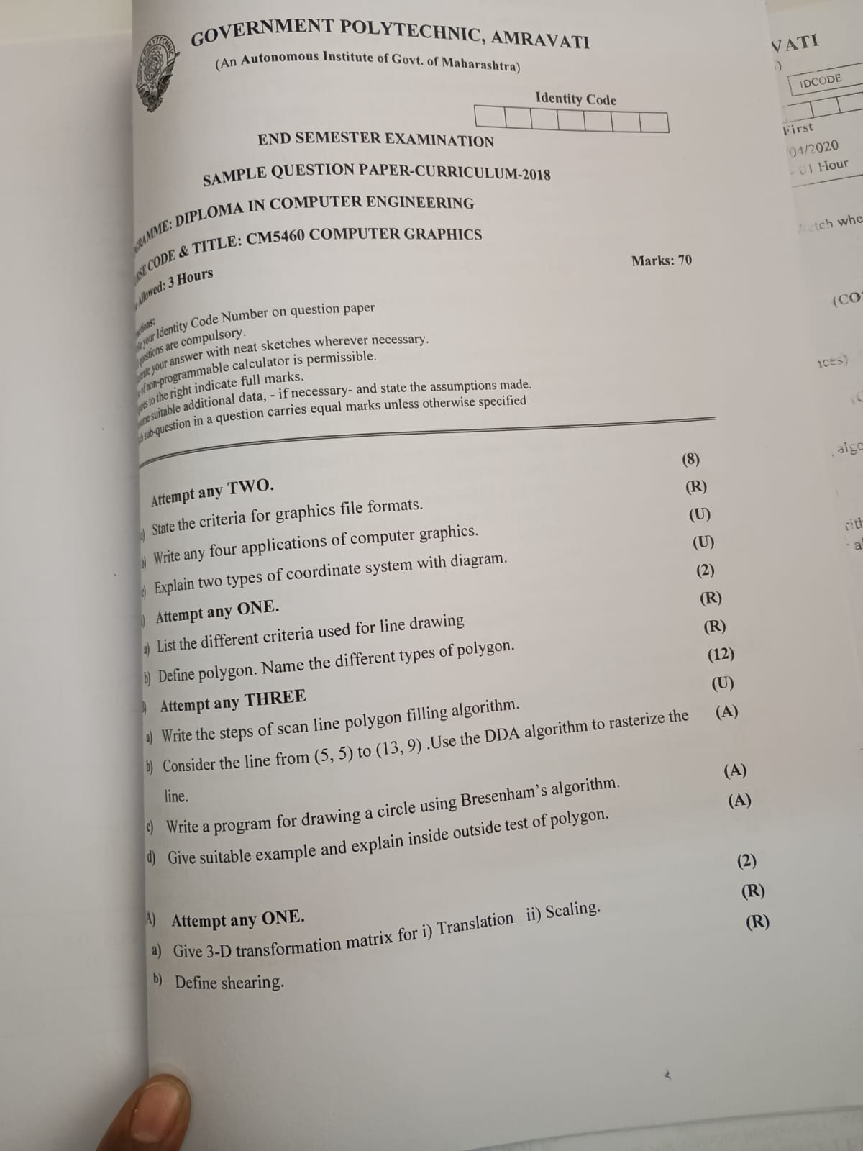

Q.1 Attempt any TWO

a) Criteria for Graphics File Formats
- Compression – Should allow for image compression (lossy/lossless).
- Transparency Support – Support for alpha channels or transparency (e.g., PNG).
- Color Depth – Ability to store a wide range of colors (e.g., 8-bit, 24-bit).
- Animation Capability – Some formats (e.g., GIF) support animations.
- Scalability – Vector formats (e.g., SVG) allow scaling without quality loss.
- Compatibility – Widely supported across software and platforms.
- File Size – Should allow optimal storage space.

b) Four Applications of Computer Graphics
- Computer-Aided Design (CAD) – Used in designing buildings, cars, aircraft.
- Entertainment – Movies, animations, games, virtual environments.
- Medical Imaging – MRI, CT scans, non-invasive diagnostics.
- Education and Training – Simulations for pilots, surgery, physics labs.
Other uses include UI design, cartography, weather maps, photo editing.

c) Two Types of Coordinate Systems with Diagram
- Cartesian Coordinate System
  - Uses x and y axes (and z in 3D).
  - Origin at (0, 0).
  - Quadrants divide 2D space.
- Polar Coordinate System
  - Represents points by radius (r) and angle (θ).
  - Useful in circular or rotational motion.
Diagram:
Cartesian:
markdown
Copy code
Y
↑
Q2 ← 0 → Q1
↓
X

Q.2 Attempt any ONE

a) Line Drawing Criteria
- Accuracy – Should pass through nearest possible pixels of the ideal line.
- Uniform Brightness – Should not vary with orientation or length.
- Efficiency – Should compute pixels quickly (preferably using integer operations).
- Simplicity – Easy to implement with minimal resources.

b) Define Polygon & Types
Polygon: A closed figure with straight lines joined end to end.
Types:
- Convex Polygon – All internal angles < 180°.
- Concave Polygon – At least one angle > 180°.
- Regular Polygon – Equal sides and angles.
- Irregular Polygon – Unequal sides or angles.

Q.3 Attempt any THREE

a) Scan Line Polygon Filling Algorithm
- Find Ymin and Ymax of the polygon.
- For each scanline:
  - Find all edge intersections.
  - Sort intersections by X coordinate.
- Fill pixels between pairs of intersections.
Efficient for filling convex and concave polygons.

b) DDA Algorithm from (5,5) to (13,9)
- dx = 13 − 5 = 8
- dy = 9 − 5 = 4
- Steps = max(dx, dy) = 8
- Δx = 1.0, Δy = 0.5
Start at (5, 5), plot points by incrementing x and y:
Points:
- (5,5)
- (6,5.5) → (6,6)
- (7,6)
- (8,6.5)
- (9,7)
- (10,7.5)
- (11,8)
- (12,8.5)
- (13,9)

c) Program for Drawing Circle using Bresenham's Algorithm
c
Copy code
#include <graphics.h>
#include <conio.h>

void drawCircle(int xc, int yc, int r) {
int x = 0, y = r;
int d = 3 - 2 * r;

while (x <= y) {
putpixel(xc+x, yc+y, WHITE);
putpixel(xc-x, yc+y, WHITE);
putpixel(xc+x, yc-y, WHITE);
putpixel(xc-x, yc-y, WHITE);
putpixel(xc+y, yc+x, WHITE);
putpixel(xc-y, yc+x, WHITE);
putpixel(xc+y, yc-x, WHITE);
putpixel(xc-y, yc-x, WHITE);

if (d < 0)
d = d + 4*x + 6;
else {
d = d + 4*(x - y) + 10;
y--;
}
x++;
}
}

void main() {
int gd=DETECT, gm;
initgraph(&gd, &gm, "");
drawCircle(200, 200, 50);
getch();
closegraph();
}

d) Inside-Outside Test of Polygon
Using Even-Odd Rule:
- Draw a horizontal ray from the point to the right.
- Count intersections with polygon edges:
  - Odd count → Point is inside.
  - Even count → Point is outside.
Also known as Ray Crossing Algorithm.
Used for clipping, fill tests, etc.

Q.4(A) Attempt any ONE

a) 3D Transformation Matrices
i) Translation Matrix:
[100Tx010Ty001Tz0001]\begin{bmatrix} 1 & 0 & 0 & Tx \\ 0 & 1 & 0 & Ty \\ 0 & 0 & 1 & Tz \\ 0 & 0 & 0 & 1 \end{bmatrix}​1000​0100​0010​TxTyTz1​​
ii) Scaling Matrix:
[Sx0000Sy0000Sz00001]\begin{bmatrix} Sx & 0 & 0 & 0 \\ 0 & Sy & 0 & 0 \\ 0 & 0 & Sz & 0 \\ 0 & 0 & 0 & 1 \end{bmatrix}​Sx000​0Sy00​00Sz0​0001​​

b) Define Shearing
Shearing is a transformation that distorts the shape of an object by shifting its coordinates in one axis, proportional to the other.
Types:
- X-shear: x' = x + sh·y
- Y-shear: y' = y + sh·x
Used for creating slanted shapes or simulating 3D perspective in 2D.
